1*4 SC APC ABS Ruggedized PLC Splitter

1x4 Planar Light wave Circuit (PLC) Splitters are based fications and high reliability that surpass Telcordia requirements and is tailored for different applications and markets.

on the Plasma Chemical Vapor Deposition (P-CVD) technology and its patented fabrication process for providing stable optical character.

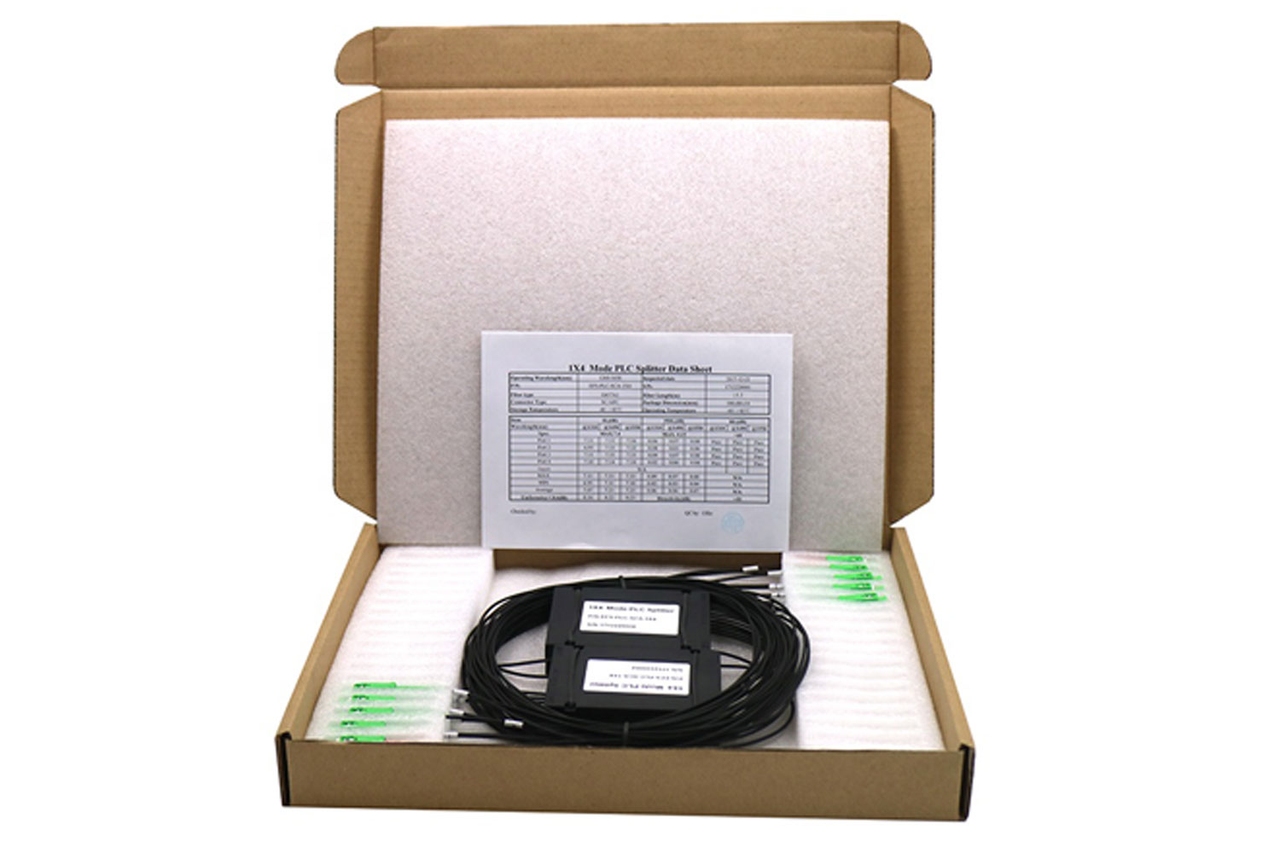

Features
• Low insertion loss
• High maximum power tolerance
• Excellent splitting uniformity
• Broadband Operating wavelength
• Compact design
• Low polarization independent

Specification

Note: Specifications without fiber connectors. Value of parameters shows at room temperature. Custom specification is also available.

1×N PLC Splitter
Parameter |  | Unit | Value
Product Type |  |  | 1×2 | 1×3 | 1×4 | 1×6 | 1×8 | 1×12 | 1×24 | 1×32 | 1×64
Operation Wavelength |  | nm | 1260～1650
Insertion Loss | Typ. | dB | 3.6 | 6 | 7 | 9.2 | 10.3 | 12.2 | 15.8 | 16.6 | 20.1
Insertion Loss | Max. | dB | 4.3 | 6.2 | 7.4 | 9.5 | 10.7 | 12.5 | 16 | 17.2 | 21.5
Uniformity (Max.) |  | dB | 0.5 | 0.6 | 0.8 | 0.8 | 0.8 | 1.2 | 1.5 | 1.5 | 2
PDL(Max.) |  | dB | 0.2 | 0.3 | 0.3 | 0.3 | 0.3 | 0.3 | 0.3 | 0.3 | 0.5
TDL(Max.) |  | dB | 0.5
Return Loss |  | dB | ≥55/50
Directivity |  | dB | ≥55

Note: All the data above does not include connectors.
UPC Connectors: IL add 0.2 dB, APC Connectors: IL add 0.3 dB.

Environmental Conditions
Operating Temperature | ℃ | -40～+85
Storage Temperature | ℃ | -40～+85
Operating Humidity | %RH | ≤93
Storage Humidity | %RH | ≤93

