MINI/Steel tube/Micro/Blockless Fiber Optical PLC Splitters

Descriptions:
PLC Splitter means planar light-wave circuit splitter, which is based on planar light wave technology, widely used in FTTX,EPOM,BPON,GPON .We launched 1xN,2XN PLC splitter with consistent performance, low optical Insertion loss, low polarization dependent Loss, high reliability and stability , superior environmental and mechanical characteristics, and fast installation. They also enable more effective monitoring and management of fiber optical networks. All wavelengths (1260-1620nm) are not sensitive. And our products meet Telcordia 1209,1221 standard ,ROHS.
We have unique competitive advantages in our PLC product platform by leveraging our strong expertise in fiber array block fabrication, our partnership with foundry service providers, and our reliable packaging technologies. Our splitters are tested based on the strictest standards of the industry, and we
guarantee quality, turnaround and competitive pricing.
The PLC splitter we offer are:1x2,1x4,1x8,1x16,1x32,1x64,2x2,2x4,2x8,2x16,2x32,2x64

Mini Blockless PLC Splitter Characteristics:
Good uniformity and low insertion loss
Low Polarization Dependent Loss
Excellent Environmental Stability
Excellent Mechanical
Stability Telecordia GR-1221 and GR-1209
Components through TLC-Certified, Conform to YD1117-2001

Mini Blockless PLC Splitter Application:
Fiber to the point (FTTX)
Fiber to the home (FTTH)
Passive optical networks(PON)
Local area networks (LAN)
Cable television (CATV)
Test equipment

Drawing Papers:
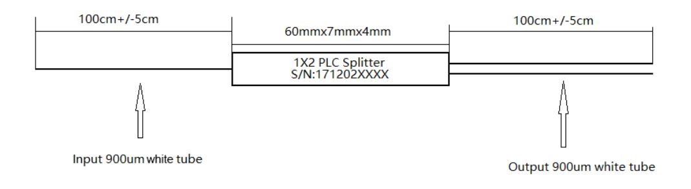

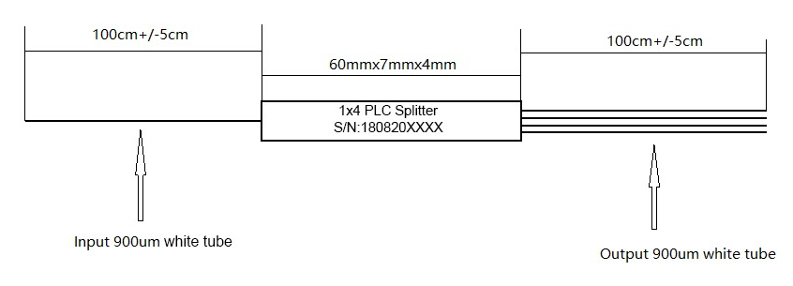
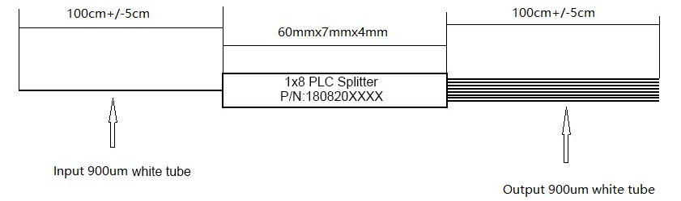

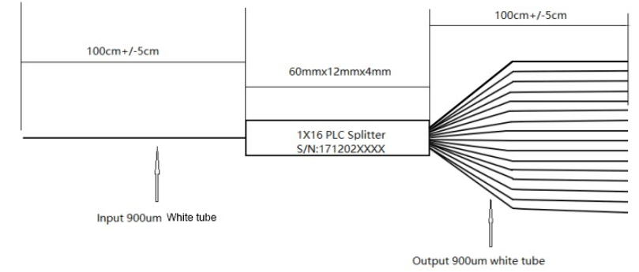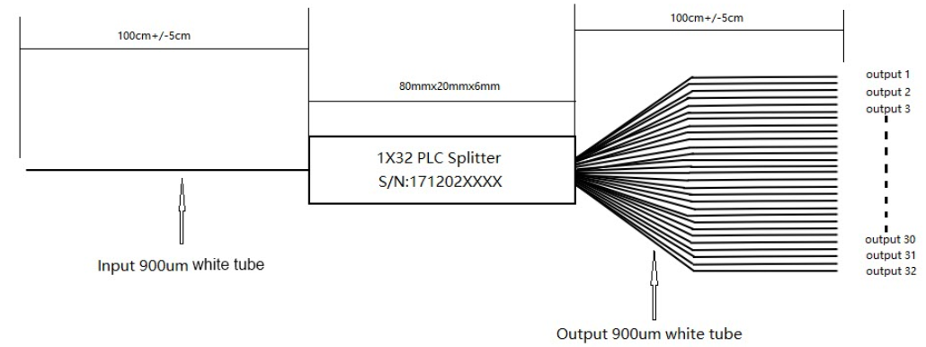

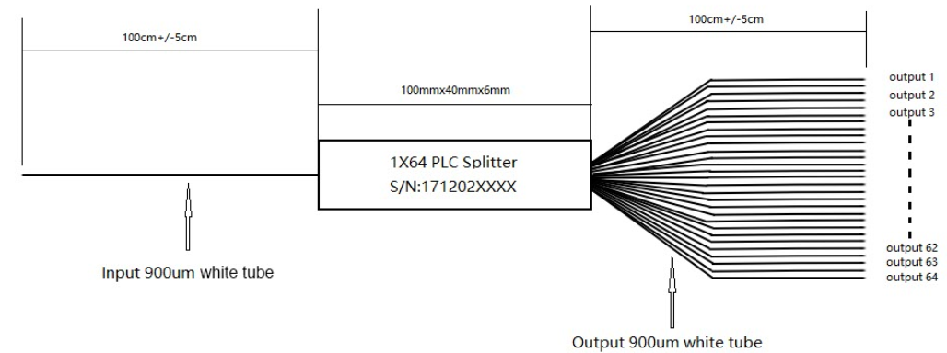

Parameters:
Type |  | 1x2 | 1×4 | 1×8 | 1×16 | 1×32 | 1×64
Operating wavelength（nm） |  | 1260-1650
Insertion loss (dB) | Typical | 3.6 | 7.1 | 10.2 | 13.5 | 16.5 | 20.2
Insertion loss (dB) | Maximum | 4 | 7.3 | 10.5 | 13.7 | 16.9 | 20.8
Uniformity (dB) | Typical | 0.4 | 0.5 | 0.6 | 1 | 1 | 2
Uniformity (dB) | Maximum | 0.6 | 0.6 | 0.8 | 1.2 | 1.5 | 2.5
Polarization Dependent Loss (dB) | Typical | 0.1 | 0.1 | 0.15 | 0.2 | 0.2 | 0.2
Polarization Dependent Loss (dB) | Maximum | 0.15 | 0.15 | 0.25 | 0.3 | 0.3 | 0.3
Wavelength dependent loss (dB) | Typical | 0.1 | 0.1 | 0.15 | 0.3 | 0.3 | 0.3
Wavelength dependent loss (dB) | Maximum | 0.2 | 0.3 | 0.3 | 0.5 | 0.5 | 0.5
Return loss (dB) | Minimum | 55/50
Directivity (dB) | Minimum | 55
Operating temperature (℃) |  | -20 to 85
Storage temperature (℃) |  | -40 to 85
Optical fiber type |  | SMF-28 Or customer required
Steel tube Size(mm) |  | 60*7*4 | 60*7*4 | 60*7*4 | 60*12*4 | 80*20*6 | 100*40*6
Optical fiber length (m) |  | 1M or customize

